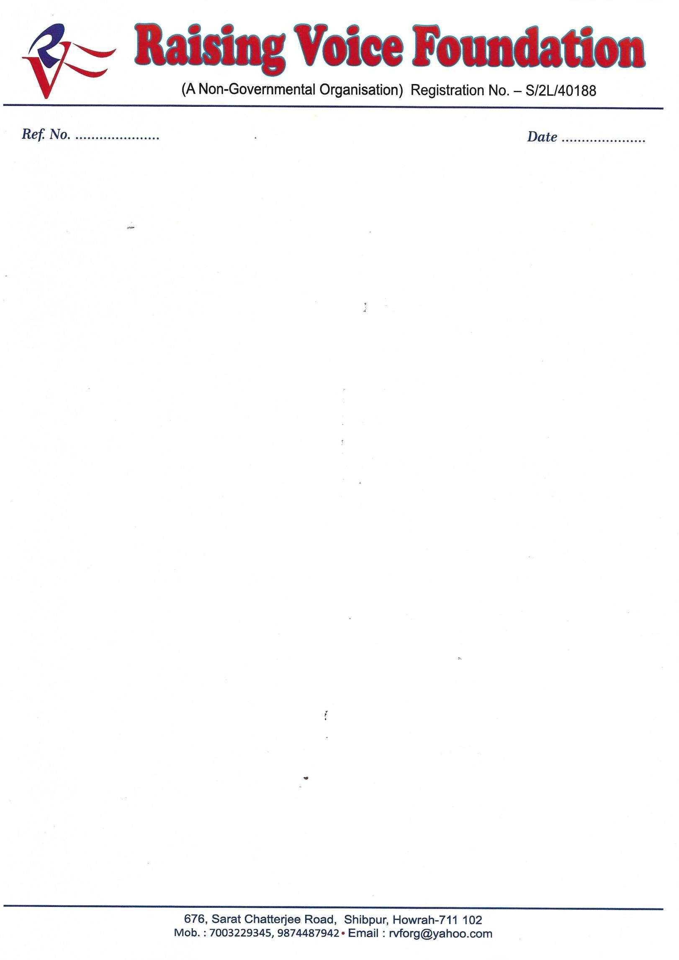

To,

Marketing

Director

AMRI

Saltlake

Kolkata

Dear Sir,

Raising Voice Foundation (RVF) takes great pleasure in announcing that w

e are organizing FREE

HEALTH CHECK UP

camp on

0

7

.

0

4

.201

9

at

**Ashok Smriti Sangha**

**Baltikuri, Howrah**

**From.10:00**

**am to 02**

**:00**

**pm.**

We also take immense pleasure and

honour

to cordially invite your panel of esteemed Doctors from

Orthopaedic

,

Cardiac

& General Medicine

department to

be a part of this event and at the same

time please enlighten our

patients present with an awareness program for

Various

types

o

f

disease patients in a simpler way, which you know better than us.

We greatly expect the strength of the patients to be odd around 200 and therefore we se

ek your solicitation for the

above cause.

It is expected that the participation of your diligent team will increase the count of patients by heaps and bounds

and therefore we humbly request you to please be a part of this EVENT.

As a token of acceptance

of the request kindly revert on this mail.

Sincerely Yours

Dr.Chandan De Hazra

Chairman Medial Committee